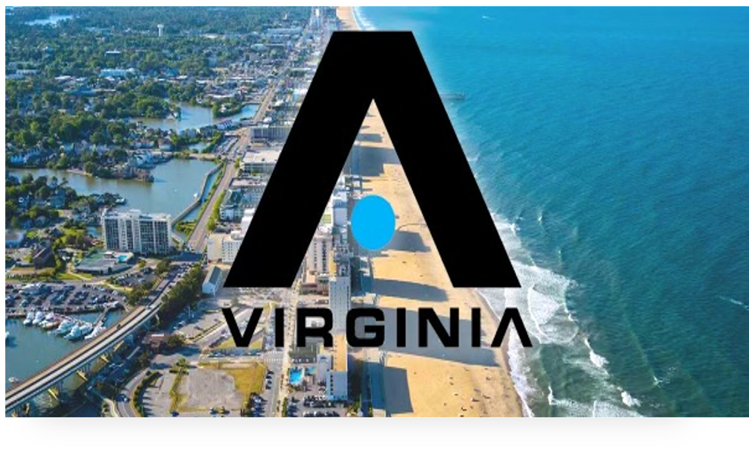

ADVNC VIRGINIA LACROSSE
PARENT HANDBOOK
2023-2024

SEPTEMBER 27, 2023

Hello ADVNC Parents and Caregivers! My name is Ryan Tucker and I am the Director of ADVNC Virginia. I couldn’t be more excited to get this club under way!
I have put together a Parent Handbook to help you navigate the club season. Lacrosse has been incredibly good to me in the 25 years I have been playing and coaching. I’ve been blessed to have some amazing experiences along the way.
My love for the game started back in the day at the Gilman School in Baltimore, MD. There, I was able to win two MIAA Championships in 2009 and 2011. I served as a captain in that 2011 championship season. Lacrosse allowed me to travel to Turku, Finland in 2012 with the USA U-19 team where I was able to win a gold medal and be selected to the All-World team as a midfielder.
My collegiate career continued at the University of Virginia where I was influenced by legendary head coach Dom Starsia and his incredible staff. I earned the ‘Spirit Award,’ USILA 3rd team All-American honors, All-ACC Academic honors, and USILA All-Academic honors. I served as a captain in 2015, my senior year.
My love for the game continued to grow as I was fortunate enough to play at the professional level for 5 years after being selected 3rd overall in the 2015 MLL Draft. In that time, I played for the Boston Cannons, Atlanta Blaze, and the Chesapeake Bayhawks. In 2019, my Bayhawks teammates and I were able to win the MLL Championship. I was voted by my teammates and other players throughout the league as ‘The Best Teammate in the MLL’ in that same season, an honor that I will cherish forever.
I am currently a teacher/coach at Norfolk Academy and have been for the past nine years. Over those nine years, we have generated dozens of lacrosse athletes that have gone on to play at the collegiate level. In that time, our varsity boys’ lacrosse team has made it to the VISAA State Semifinals five of the last seven full seasons and to the VISAA finals one of those seasons. In my four years as the head coach, I have been named TCIS Coach of the Year twice, having won two TCIS Championships. In 2023, Norfolk Academy won the LIS ‘Sportsmanship Award.’ I also received Norfolk Academy’s Excellence in Coaching award in 2022.
Most importantly, however, is my love for my family. I have been married to my amazing wife, Kirkland, for two and a half years. Together, we have the most amazing baby boy, Littleton, who we call ‘Lit.’
I share all of this to give you a little background as to what has shaped me into a player/coach and a mentor/role model for your sons. I also want you to understand the value I place on family, relationships, and the consistent pursuit of excellence. I hope you enjoy this Parent Handbook.

PARENT HANDBOOK TABLE OF CONTENTS

PHILOSOPHY AND OBJECTIVES_____________________________________________________ 4

HOW WE BUILD CULTURE_________________________________________________________ 5

HOW WE COACH________________________________________________________________ 6

PARENT PARTNERSHIP___________________________________________________________ 7

THE ADVNC TRAINING PROGRAM__________________________________________________ 8

LOOKING AHEAD________________________________________________________________ 9

PHILOSOPHY AND OBJECTIVES
At ADVNC Virginia, our philosophy is to teach, inspire, motivate and empower our players to be fundamentally sound, physically fit, and mentally tough by demanding their very best effort and holding them to the highest standards on the lacrosse field and in life. Our aim is to build better people and better players through the game of lacrosse. We will do this by creating a competitive culture that focuses on building fundamental skills and a strong lacrosse IQ. Our youngest levels will focus on laying the foundation of strong fundamentals. Tournaments will gradually increase in difficulty as our players get older and more skilled.

Through lacrosse, we strive to instill a sense of responsibility, loyalty, compassion for others, and sportsmanship in victory as well as defeat. In order to build young men of character, the focus will not only be winning on the field, but off of it as well. Intentional practices, calculated competitions, energized and constructive coaching, and trust in the process will contribute to this end. We will not stand for issues that arise academically or socially that hinder the development of an individual and deter the growth of our program.

Our primary goal is to develop young men that demonstrate, by their words and their actions, that they are “class” athletes and people – on and off the playing field.

HOW WE BUILD CULTURE

Successful programs create a palpable culture, with sound habits and high standards. This is how we build our ADVNC Virginia culture:

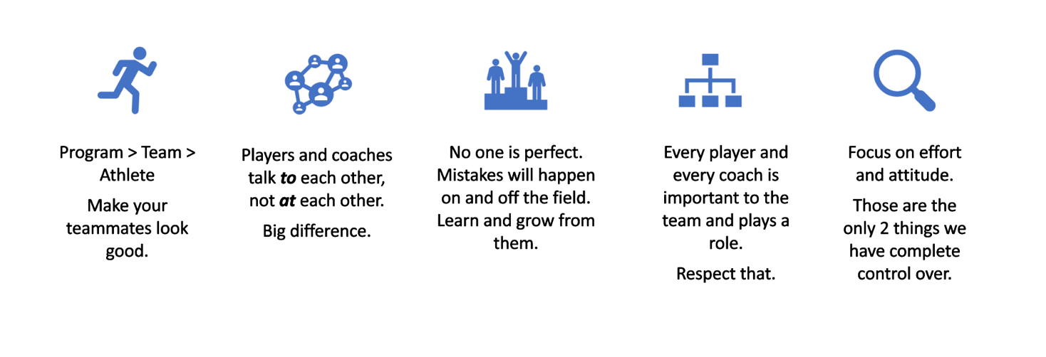
We are building better people and better players through the game of lacrosse.

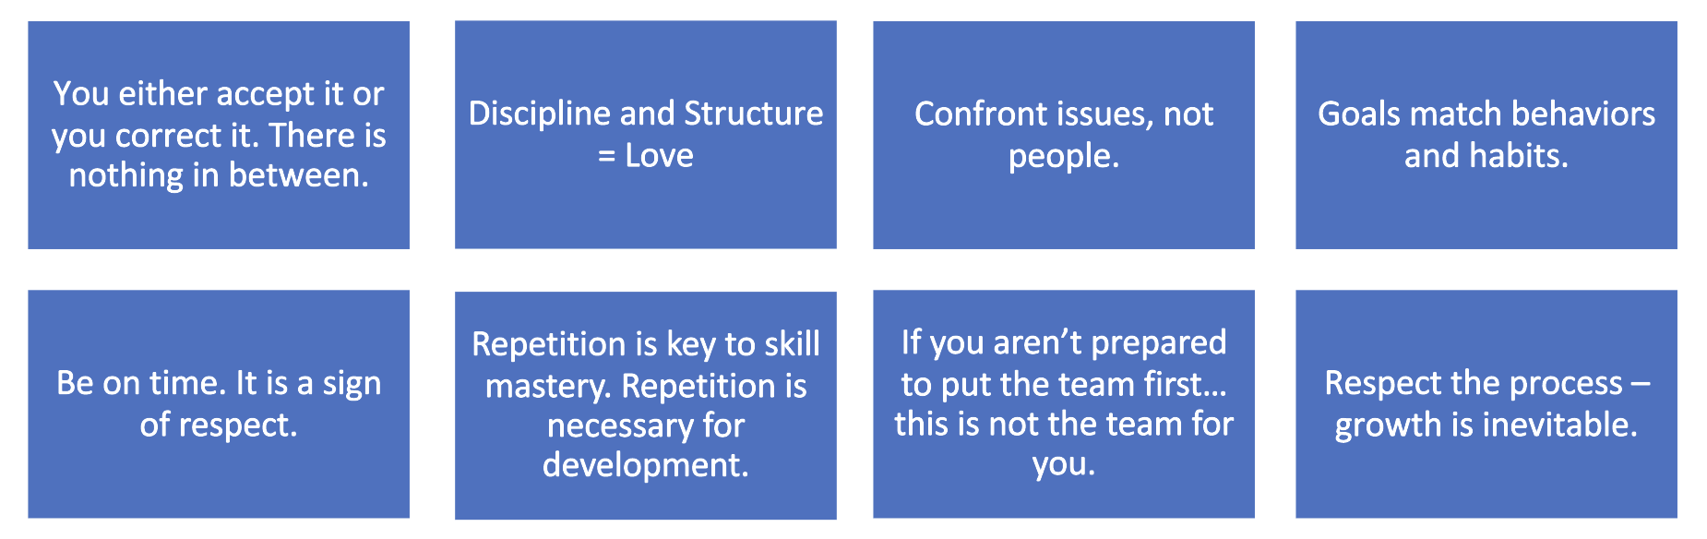

HOW WE COACH

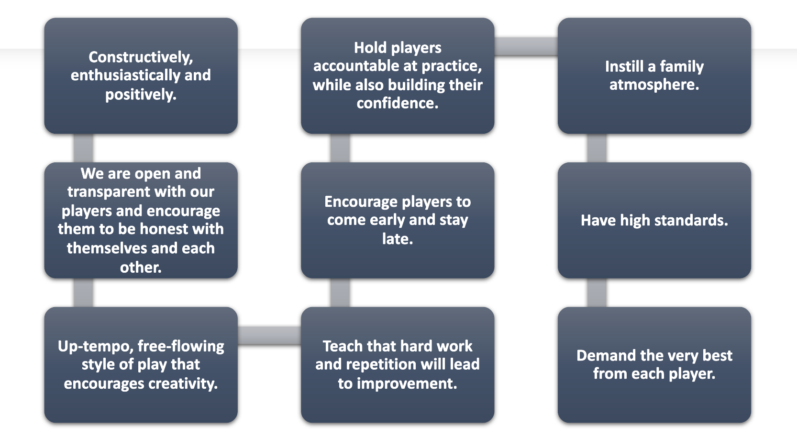

PARENT PARTNERSHIP
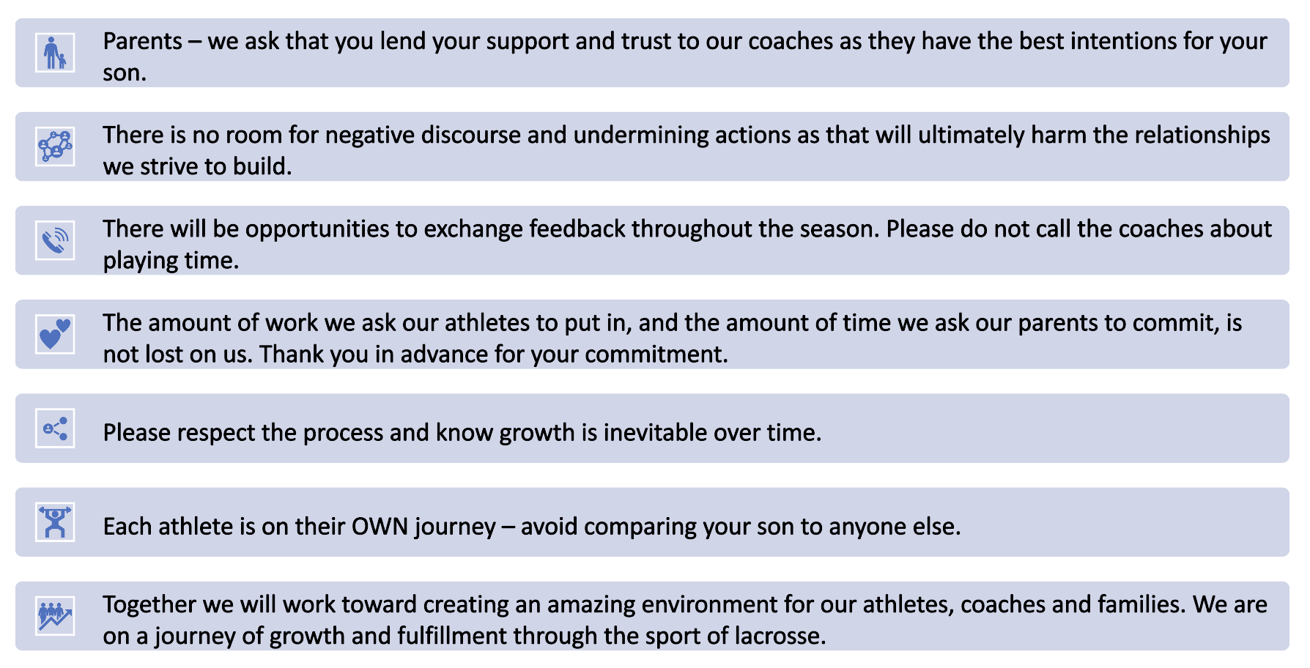

THE ADVNC TRAINING PROGRAM
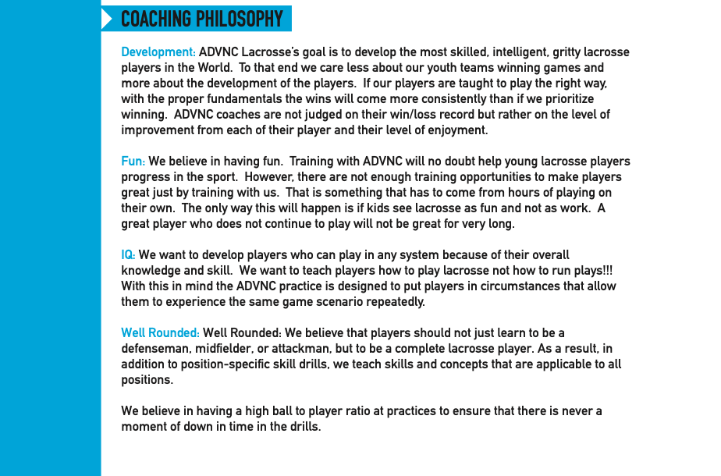

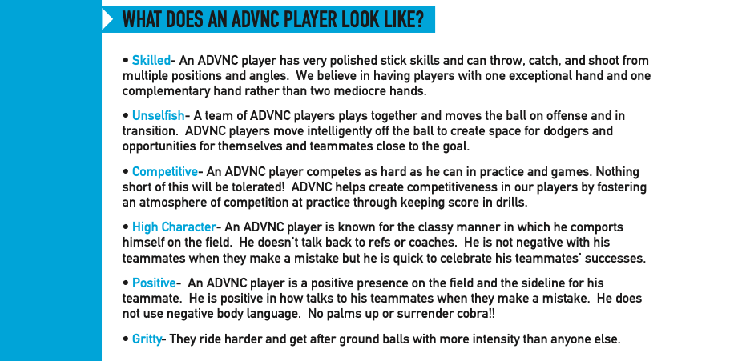

LOOKING AHEAD
Our goal is to become the premier club in not only the Hampton Roads area, but all of Virginia. In order to do that, we are looking to compile the best players we can at every age level. We will have one team per age group and will host tryouts annually for these age groups. Please encourage others to trust our system and our brand as you come across talented players in our immediate area and beyond. I could not be more excited for what’s to come. Here we go!

Please don’t hesitate to reach out if you have any questions or concerns – rtucker@norfolkacademy.org

